E-learning Research

Contents

Problem analysis 2

Context 2

Target Audience 2

Goal 2

Research Questions 3

Main research question 3

Sub-questions 3

Research Methods & Strategies 3

Library – Competitor research 3

Validation research method 3

Sources and their validation 3

Results 3

Library – Best and good practices 4

Skillshare 4

Udemy 4

Udacity 4

Library – Bad practices 5

Skillshare 5

Udemy 5

Udacity 5

Conclusion 5

Sub-questions 5

“What are the top 3 software development e-learning platforms?” 5

“What are common best practices regarding software development e-learning?” 6

“What are things to avoid regarding software development e-learning?” 6

Main question 6

Sources 6

# Problem analysis

## Context

The context for this research is the duo-application assignment regarding the Android platform of the fourth semester within the ICT track at Fontys Hogescholen Eindhoven. The project is an e-learning roadmap application where users can develop and share personal roadmaps in order to specifically get the information they need instead of following a generalized tutorial.

## Target Audience

The target audience is based on a given persona. The persona is business owner Simon and is described in the picture below.

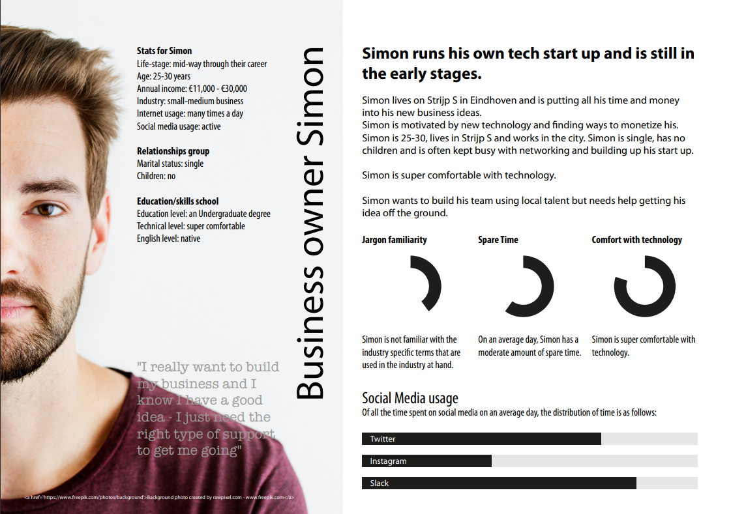

Simon is a relatively young startup owner that wants to expand his business using local talent. He runs a tech company but has trouble implementing his ideas on his own. He therefor has a need for learning just the subjects he needs to implement these ideas, and will therefor have a need for this concept.

## Goal

This research aims to compile a list of best practices and don’t for implementing an e-learning environment. The list will then be used as reference in the development process of the roadmap application project, in order to provide users with the best possible experience.

# Research Questions

## Main research question

*“How can the roadmap app implement common best practices and avoid bad practices regarding software development e-learning?”*

## Sub-questions

1. *“What are the top 3 software development e-learning platforms?”*
2. *“What are common best practices regarding software development e-learning?”*
3. *“What are things to avoid regarding software development e-learning?”*

# Research Methods & Strategies

## Library – Competitor research

### Validation research method

In order to compile a list of the three most used e-learning platform and answer the first research question competitor research was performed. This is the most accurate way of finding the most used platforms.

### Sources and their validation

The sources used for this research is source 1 and 2. The writer of source 1 is a valid source because of her educational background and experience. The article was also fact-checked by a valid editor/writer. Source 2 is valid because the author of the website is Google.

### Results

For these results provided below, the term ‘best e learning platform’ was googled. Source one and two were discovered by doing so.

After looking at the courses mentioned in both source one and two some e-learning platforms were excluded from the equation as they have limited to no software courses available.

The article cited in source one concludes Udemy as the best overall e-learning tool. It also describes Udacity as the best e-learning platform when it comes to Tech. The second source praises Skillshare as the best e-learning platform, while the first source describes Skillshare as the best for Creative Fields.

Source two also mentions Udemy and Udacity as very good options and puts them at places four and six respectively.

The three most relevant and most used e-learning platforms when it comes to software development are:

1. [Skillshare](https://www.skillshare.com/?via=header)
2. [Udemy](https://www.udemy.com/)
3. [Udacity](https://www.udacity.com/)

However the order of the three comes down to personal preference. Therefor the platforms listed above are not ranked and are equally reliable from a subjective standpoint.

## Library – Best and good practices

In order to compile a best and good practices list that are common the three ‘best’ e-learning platforms were reviewed. For the creation of this research sources 4, 5 and 6 are used.

### Skillshare

Skillshare is a good option if you like interacting with a community of like-minded students. Skillshare is also aimed at providing great bulk prices, so if you are a business owner that needs to buy multiple you pay less per account based on how many you purchase in total. Skillshare also has a mobile application for users to enjoy. It also utilizes a freemium model where some classes are available for free and others are paid. The courses are separated into digestible time boxes of approximately 10 minutes. This enables the user to work at their own pace, in their own time. The list below sums up these best and good practices that are implemented into Skillshare.

* Community
* Bulk pricing
* Mobile application
* Freemium model
* Short videos for working on your own pace

### Udemy

Udemy has a lot of categories and supports good navigation within their website. There are a lot of courses available on Udemy. The filtering works like a charm and courses are easy to find. The payment per course means that you are not tied to any priced planning shenanigans. There are reviews to be found about every course from different students. Courses are often on sale, meaning that they approximately cost about 15 dollars per course. Udemy also has free courses. Udemy also has a mobile application for users. The list below sums up all the good and best practices Udemy utilizes:

* A lot of categories
* Good navigation
* A lot of courses
* Good filtering
* Payment on a course base
* Free courses
* Mobile application
* Reviews

### Udacity

Udacity provides their users with nanodegree programs. These are very helpful if you are looking to expand your resume or professional skillset. Udacity also has some resume related features, where pro’s will look at your resume or LinkedIn page and give feedback. The courses are taught by a licensed professionals and are often vast. The list provided below sums up the best and good practices used by Udacity.

* Career/resume based courses
* Nanodegree
* Resume features
* Lengthy courses
* Licensed teachers

## Library – Bad practices

In order to compile a list of bad practices the three ‘best’ e-learning platforms were analyzed and reviews about them were read. For the creation of this research sources 3, 4, 5 and 6 are used.

### Skillshare

Skillshare has some features that people aren’t as much of a fan of. The list below describes the main issues people have found and encountered.

* Student feedback isn’t insightful
* Teachers are not mandated to participate in the community features
* The navigation within the website is not intuitive
* An account is required to see individual pricing

### Udemy

Udemy’s double-edged sword is their review system. Although the reviews can be helpful prior to purchasing a course, it is often misleading because one user might have paid the full price (e.g. $150) and have totally different expectation than a user that got it at a discount and only paid $10. Anyone can teach at Udemy, so even though this might mean there are a lot of courses, this mostly means that not all of them are as valid or good. The pricing for teams is relatively high. Because of the amount of courses, a lot of the courses available are quite old or even outdated. The list below sums up the bad practices Udemy follows:

* Review system
* Anyone can teach
* Old or outdated courses

### Udacity

There are some downsides to Udacity. Namely, the pricing. The courses are very expensive as they provide a lot of career/resume features and offer nanodegree programs. For the same reason, there are not a lot of reviews available as the courses are pricy. The navigation on the main website is not intuitive. The free courses provided by Udacity are not that interesting or outdated. The list below describes the bad practices that are inherent on the Udacity platform:

* Expensive courses
* Not a lot of project reviews
* Website navigation
* ‘bad’ free courses.

# Conclusion

## Sub-questions

### “What are the top 3 software development e-learning platforms?”

The top three most used e-learning platforms for software development are Skillshare, Udacity and Udemy.

### “What are common best practices regarding software development e-learning?”

Main best and good practices to follow regarding e-learning for software development are:

* Community/reviews implementation
* Bulk pricing options
* Mobile applications
* Freemium model support
* Short, time boxable videos
* Good and intuitive website design
* Licensed teachers and instructors
* Categorization
* Filtering when looking for courses

### “What are things to avoid regarding software development e-learning?”

Things to avoid while developing an e-learning platform for software engineering are:

* Outdated or old course materials
* Misleading reviews because of constant sales
* High pricing
* Anyone can teach system

## Main question

“How can the roadmap app implement common best practices and avoid bad practices regarding software development e-learning?”

The result from the previous two researches are compiled into one list, providing information on what to implement and what to avoid when it comes to developing and e-learning environment.

|  |  |
| --- | --- |
| **Good practices** | **Bad practices** |
| Community/reviews | Outdated courses |
| Bulk pricing | Misleading review system |
| Mobile application | High pricing |
| Freemium model | Anyone can teach system |
| Short videos |  |
| Good/intuitive navigation |  |
| Licensed instructors |  |
| Categories |  |
| Good filtering |  |

# Sources

1. Prahl, A. (2020, October 24). The 7 Best Online Learning Platforms of 2021. Retrieved March 1, 2021, from <https://www.verywellfamily.com/best-online-learning-platforms-5073725>
2. Google. (n.d.). List Of 8 Best Online Learning Platforms 2021 | Online Courses Websites. Retrieved March 1, 2021, from <https://sites.google.com/site/videoblocksreview/online-learning-platforms>
3. PCMag. (2020, May 27). Skillshare Review. Retrieved March 2, 2021, from <https://www.pcmag.com/reviews/skillshare>
4. Learn the Latest Tech Skills; Advance Your Career | Udacity. (n.d.). Retrieved March 2, 2021, from <https://www.udacity.com/>
5. Skillshare for Teams | Online Learning Platform. (n.d.). Retrieved March 2, 2021, from <https://teams.skillshare.com/>
6. Udemy. (n.d.). Online Courses - Learn Anything, On Your Schedule. Retrieved March 2, 2021, from <https://www.udemy.com/>